

Semester Two Examination, 2020

Question/Answer booklet

MATHEMATICS

SOLUTIONS
SPECIALIST
UNITS 1&2

Section Two:

Calculator-assumed

WA student number: In figures

In words

Your name

Number of additional
answer booklets used
(if applicable):

Time allowed for this section
Reading time before commencing work: ten minutes
Working time: one hundred minutes

Materials required/recommended for this section
To be provided by the supervisor
This Question/Answer booklet
Formula sheet (retained from Section One)

To be provided by the candidate
Standard items: pens (blue/black preferred), pencils (including coloured), sharpener,
correction fluid/tape, eraser, ruler, highlighters

Special items: drawing instruments, templates, notes on two unfolded sheets of A4 paper, and up to three calculators approved for use in this examination

Important note to candidates
No other items may be taken into the examination room. It is your responsibility to ensure that you do not have any unauthorised material. If you have any unauthorised material with you, hand it to the supervisor before reading any further.

Structure of this paper

Section | Number of  questions  available | Number of  questions to  be answered | Working  time  (minutes) | Marks  available | Percentage  of  examination
Section One:  Calculator-free | 8 | 8 | 50 | 52 | 35
Section Two:  Calculator-assumed | 13 | 13 | 100 | 98 | 65
 |  |  |  | Total | 100

Instructions to candidates

1. The rules for the conduct of examinations are detailed in the school handbook. Sitting this examination implies that you agree to abide by these rules.

2. Write your answers in this Question/Answer booklet preferably using a blue/black pen.
Do not use erasable or gel pens.

3. You must be careful to confine your answers to the specific question asked and to follow any instructions that are specific to a particular question.

4. Show all your working clearly. Your working should be in sufficient detail to allow your answers to be checked readily and for marks to be awarded for reasoning. Incorrect answers given without supporting reasoning cannot be allocated any marks. For any question or part question worth more than two marks, valid working or justification is required to receive full marks. If you repeat any question, ensure that you cancel the answer you do not wish to have marked.

5. It is recommended that you do not use pencil, except in diagrams.

6. Supplementary pages for planning/continuing your answers to questions are provided at the end of this Question/Answer booklet. If you use these pages to continue an answer, indicate at the original answer where the answer is continued, i.e. give the page number.

7. The Formula sheet is not to be handed in with your Question/Answer booklet.
Section Two: Calculator-assumed 65% (98 Marks)
This section has thirteen questions. Answer all questions. Write your answers in the spaces provided.

Working time: 100 minutes.

Question 9 (6 marks)
(a) Prove that the opposite angles of a cyclic quadrilateral are supplementary. (3 marks)
Solution
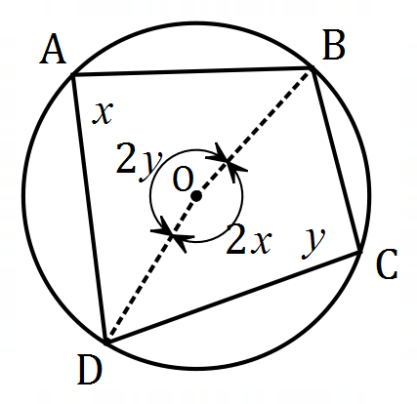
Required to prove that $x+y=180°$
$$B\hat{O}D=2×B\hat{A}D=2x \text{(Angle at centre-circumference)}$$
$$B\check{O}D=2×B\hat{C}D=2y \text{(Angle at centre-circumference)}$$
$$2x+2y=360° \text{(Angle at a point)}$$
Hence $x+y=180°$ as required.

Specific behaviours
diagram and states required to prove
ü uses angles at centre and on circumference
ü completes proof

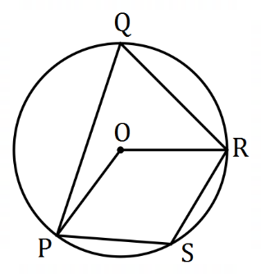

(b) The points $P, Q, R$ and $S$ lie on
the circle with centre $O$ so that
$PS=RS$ and $∠PQR=48°$.
Determine the size of $∠ORS$.
(3 marks)
Solution
$$∠PSR=180°-48°=132° \\ ΔROS≡ΔPOS \text{(SSS)} \\ ∠OSR=132°÷2=66° \\ ∠ORS=∠OSR=66°$$

Specific behaviours
states an angle in $PORS$
ü indicates property of $PORS$ (kite, congruency, etc)
ü correct angle

Question 10 (6 marks)
(a) Triangle $ABC$ has vertices $A\left(-1, 4\right), B(7, 8)$ and $C(7, -4)$. Determine the area of this triangle after it has been transformed using the matrix $\left[\begin{matrix}5 & 5 \\ 3 & -3\end{matrix}\right]$. (3 marks)
Solution
Area of $ΔABC=\frac{1}{2}×12×8=48$.

Determinant of transformation matrix $=-30$.

Area of transformed triangle $=\left|-30\right|×48=1 440$ square units.

Specific behaviours
area of $ΔABC$
ü correct use of determinant
ü correct area

(b) Show use of matrix algebra, including the coefficients of any inverse matrix used, to solve the following system of linear equations: (3 marks)

$$5s+3t=7 \\ 7s+4t=15$$
Solution
$$\left[\begin{matrix}5 & 3 \\ 7 & 4\end{matrix}\right]\left[\begin{matrix}s \\ t\end{matrix}\right]=\left[\begin{matrix}7 \\ 15\end{matrix}\right]$$

$$\left[\begin{matrix}p \\ q\end{matrix}\right]={\left[\begin{matrix}5 & 3 \\ 7 & 4\end{matrix}\right]}^{-1}\left[\begin{matrix}7 \\ 15\end{matrix}\right] \\ =\frac{1}{-1}\left[\begin{matrix}4 & -3 \\ -7 & 5\end{matrix}\right]\left[\begin{matrix}7 \\ 15\end{matrix}\right] \left(\text{or uses} \left[\begin{matrix}-4 & 3 \\ 7 & -5\end{matrix}\right]\right) \\ =\left[\begin{matrix}17 \\ -26\end{matrix}\right]$$

Specific behaviours
writes system in matrix form
ü matrix expression for solution, including inverse
ü correct solution

Question 11 (8 marks)
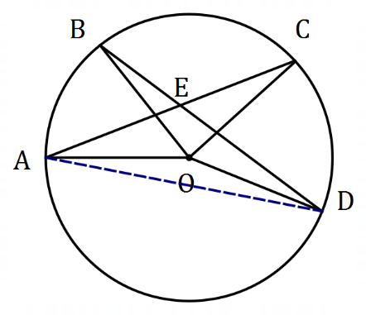
(a) In the diagram shown (not to scale)
$A, B, C$ and $D$ lie on a circle centre $O$
and chords $AC$ and $BD$ intersect at $E$.
$∠AOB=55°$ and $∠COD=62°$.
Determine, with reasons, the size
of $∠CED$.

(4 marks)
Solution
$∠ADB=\frac{1}{2}×55°=27.5°$ (angle at centre-circumference)

$∠CAD=\frac{1}{2}×62°=31°$ (angle at centre-circumference)

$∠CED=27.5°+31°=58.5°$ (sum of opposite interior angles)

Specific behaviours
adds chord $AD$ (or $BC$)
$∠ADB$ with reason
ü $∠CAD$ with reason
ü $∠CED$ with reason

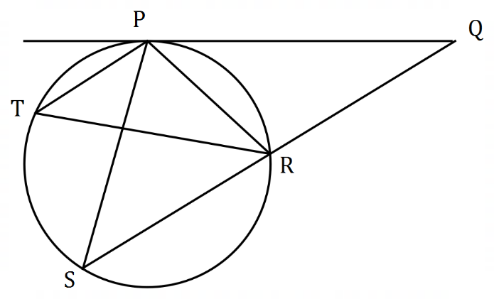
(b) In the diagram shown (not to scale)
$QRS$ is a straight line and $P, R, S$ and
$T$ lie on a circle.
$PQ$ is a tangent to the circle at $P$,
$∠SPR=54°$ and $∠RTP=39°$.
Determine, with reasons, the size
of $∠PQR$.

(4 marks)
Solution
$∠PSR=39°$ (angles on same arc $PR$)

$∠QPR=39°$ (alternate segment theorem)

$∠SPQ=39°+54°=93°$ (adjacent angles)

$∠PQR=180°-93°-39°=48°$ (angle sum in $ΔPQS$)

Specific behaviours
$∠PSR$ with reason
ü $∠QPR$ with reason
ü $∠SPQ$ with reason
ü $∠PQR$ with reason

Question 12 (8 marks)
The vertices of triangle $T$ are $A(-4, -3)$, $B(13, 6)$ and $C(-2, 8)$.

Transformation $M$ is a translation by vector $\left[\begin{matrix}7 \\ -6\end{matrix}\right]$.

(a) State the coordinates of the image of $A$ after triangle $T$ is transformed by $M$. (1 mark)

Solution
$$\left[\begin{matrix}-4 \\ -3\end{matrix}\right]+\left[\begin{matrix}7 \\ -6\end{matrix}\right]=\left[\begin{matrix}3 \\ -9\end{matrix}\right]⇒A'(3, -9)$$

Specific behaviours
correct coordinates

Transformation $N$ is a reflection in the line $y=x$.

(b) Determine the transformation matrix for $N$ and state the coordinates of the image of $B$ after triangle $T$ is transformed by $M$ and then by $N$. (3 marks)
Solution
$$N=\left[\begin{matrix}0 & 1 \\ 1 & 0\end{matrix}\right]$$

$$B^{'}=\left[\begin{matrix}13 \\ 6\end{matrix}\right]+\left[\begin{matrix}7 \\ -6\end{matrix}\right]=\left[\begin{matrix}20 \\ 0\end{matrix}\right]$$

$$B^{''}=\left[\begin{matrix}0 & 1 \\ 1 & 0\end{matrix}\right]\left[\begin{matrix}20 \\ 0\end{matrix}\right]=\left[\begin{matrix}0 \\ 20\end{matrix}\right]$$

$$B''(0, 20)$$

Specific behaviours
matrix for $N$
ü transforms $B$ by $M$
ü coordinates of $B''$

Transformation $P$ is a rotation of $45°$ clockwise about the origin.

(c) Determine the exact coordinates of the image of $C$ after triangle $T$ is transformed by $N$ and then by $P$. (3 marks)
Solution
$$P=\left[\begin{matrix}\cos{(-45°)} & -\sin{(-45°)} \\ \sin{(-45°)} & \cos{(-45°)}\end{matrix}\right]=\left[\begin{matrix}\frac{\sqrt{2}}{2} & \frac{\sqrt{2}}{2} \\ \frac{-\sqrt{2}}{2} & \frac{\sqrt{2}}{2}\end{matrix}\right]$$

$$C^{'}=\left[\begin{matrix}0 & 1 \\ 1 & 0\end{matrix}\right]\left[\begin{matrix}-2 \\ 8\end{matrix}\right]=\left[\begin{matrix}8 \\ -2\end{matrix}\right]$$

$$C^{''}=\left[\begin{matrix}\frac{\sqrt{2}}{2} & \frac{\sqrt{2}}{2} \\ \frac{-\sqrt{2}}{2} & \frac{\sqrt{2}}{2}\end{matrix}\right]\left[\begin{matrix}8 \\ -2\end{matrix}\right]=\left[\begin{matrix}3\sqrt{2} \\ -5\sqrt{2}\end{matrix}\right]$$

$$C''(3\sqrt{2}, -5\sqrt{2})$$

Specific behaviours
matrix for $P$
ü transforms $C$ by $N$
ü coordinates of $C''$

(d) Write a matrix expression for the transformation matrix $Q$ that represents the inverse of transformation $N$ followed by the inverse of transformation $P$. There is no need to simplify your expression. (1 mark)
Solution
N.B. $N^{-1}$ can be replaced with $N$ below, as $N$ is self inverse.

$$Q=P^{-1}×N^{-1}$$
Or
$$Q={\left[\begin{matrix}\frac{\sqrt{2}}{2} & \frac{\sqrt{2}}{2} \\ \frac{-\sqrt{2}}{2} & \frac{\sqrt{2}}{2}\end{matrix}\right]}^{-1}×{\left[\begin{matrix}0 & 1 \\ 1 & 0\end{matrix}\right]}^{-1}$$
Or
$$Q={\left(NP\right)}^{-1}$$
Or
$$Q={\left(\left[\begin{matrix}0 & 1 \\ 1 & 0\end{matrix}\right]×\left[\begin{matrix}\frac{\sqrt{2}}{2} & \frac{\sqrt{2}}{2} \\ \frac{-\sqrt{2}}{2} & \frac{\sqrt{2}}{2}\end{matrix}\right]\right)}^{-1}$$

Specific behaviours
any correct expression

Question 13 (8 marks)
Two vectors are $a=\left(\begin{matrix}-64 \\ 252\end{matrix}\right)$ and $b=\left(\begin{matrix}168 \\ -99\end{matrix}\right)$. Determine

(a) the magnitude of $b$. (1 mark)
Solution
$$\sqrt{{168}^{2}+{99}^{2}}=195$$

Specific behaviours
correct magnitude

(b) the angle between the directions of $a$ and $\left(\begin{matrix}1 \\ 0\end{matrix}\right)$. (2 marks)
Solution
$$\cos^{-1}{\frac{-64}{260}}=104.3° \text{(or using CAS)}$$

Specific behaviours
indicates correct method
ü correct angle to nearest degree

(c) the value of the scalar constant $t$ so that $ta+8b$ is parallel to $\left(\begin{matrix}0 \\ 1\end{matrix}\right)$. (2 marks)
Solution
$$t\left(\begin{matrix}-64 \\ 252\end{matrix}\right)+8\left(\begin{matrix}168 \\ -99\end{matrix}\right)=a\left(\begin{matrix}0 \\ 1\end{matrix}\right) \\ -64t+8(168)=0 \\ t=21$$

Specific behaviours
equation with $t$
ü value of $t$

(d) a vector $c$ that is perpendicular to $a$ with the magnitude of $b$. (3 marks)
Solution
$$c=k\left(\begin{matrix}0 & 1 \\ -1 & 0\end{matrix}\right)\left(\begin{matrix}-64 \\ 252\end{matrix}\right)=k\left(\begin{matrix}252 \\ 64\end{matrix}\right)$$

$$\left|k\right|=\frac{195}{260}⇒k=±0.75$$

$$c=\left(\begin{matrix}189 \\ 48\end{matrix}\right) \left(\text{or} c=\left(\begin{matrix}-189 \\ -48\end{matrix}\right)\right)$$

Specific behaviours
rotates vector $90°$
ü ratio of magnitudes
ü any correct vector

Question 14 (8 marks)
(a) Determine the number of integers between $1$ and $749$ that are

(i) divisible by $72$. (1 mark)
Solution
$$\left\lfloor 749÷72\right\rfloor =10$$

Specific behaviours
correct number

(ii) divisible by $8$ or by $9$ but not by $72$. (3 marks)
Solution
Divisible by $8, 9$:
$$\left\lfloor 749÷8\right\rfloor =93$$
$$\left\lfloor 749÷9\right\rfloor =83$$
Divisible by $8$ or $9$:
$$93+83-10=166$$
Divisible by $8$ or $9$ but not $72$:
$$166-10=156$$

Specific behaviours
numbers divisible by $8, 9$
ü number divisible by $8$ or $9$
ü correct answer

(b) A playlist offered by a music streaming service has $15$ different songs. Every time a playlist is streamed, the songs are shuffled into a random arrangement.

Show that after the playlist has been streamed $75 000$ times, at least $3$ of those streams began with the same $4$ songs in the same order. (4 marks)
Solution
Number of different arrangements for first $4$ songs:

$$^{15}P_{4}=32 760$$

Using the pigeonhole principle, we have $75 000$ pigeons to place in $32 760$ pigeonholes.

$$\left\lceil 75000÷32760\right\rceil =3$$

Hence at least $3$ of the streams must have begun with the same $4$ songs in the same order.

Specific behaviours
number of arrangements
ü identifies pigeons
ü identifies pigeonholes
ü uses pigeonhole principle to draw conclusion

Question 15 (8 marks)
(a) State whether each of the following statements are true or false, supporting each answer with an example or counterexample.

(i) $∀n∈N$, $5^{n}-2$ is prime. (2 marks)
Solution
False.
When $n=3, 5^{3}-2=123=3×41$ - not prime.

Specific behaviours
states false
ü valid counterexample

(ii) $∀a, b, c, d∈R,$ if $a>b$ and $c>d$ then $ac>bd$. (2 marks)
Solution
False.
Let $a=1, b=-2$ and $c=0, d=-3.$
Then $a>b$ and $c>d$ but $ac=0$ and $bd=6⇒ac<bd$.

Specific behaviours
states false
ü valid counterexample

(b) Prove by contradiction that $PQRS$ is not a cyclic quadrilateral if diagonal $PR$ of length
$11$ cm cuts diagonal $QS$ of length $14$ cm at $T$ so that $PT=ST=6$ cm. (4 marks)
Solution
Assume that $PQRS$ is a cyclic quadrilateral, as shown below:
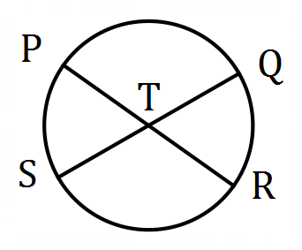$RT=11-6=5$ cm and $QT=14-6=8$ cm.

By the intersecting chord theorem, $PT×RT=QT×ST$

However, $PT×RT=6×5=30$ but $QT×ST=8×6=48$ which contradicts our initial assumption and so $PQRS$ is not a cyclic quadrilateral.

Specific behaviours
states assumption that quadrilateral is cyclic
ü calculates correct segment lengths
ü uses intersecting chord theorem
ü indicates contradiction

Question 16 (8 marks)
Starting at midnight ($t=0$), the temperature $T$ at a campsite was observed to vary sinusoidally over the course of the day, reaching a high of $18.2°$C at $1$ pm after a low of $-7.4°$C at $1$ am. Let $t$ be the time in hours from midnight.

(a) Use the above information to sketch a graph showing how $T$ varies with $t$ during the day.
(2 marks)
Solution
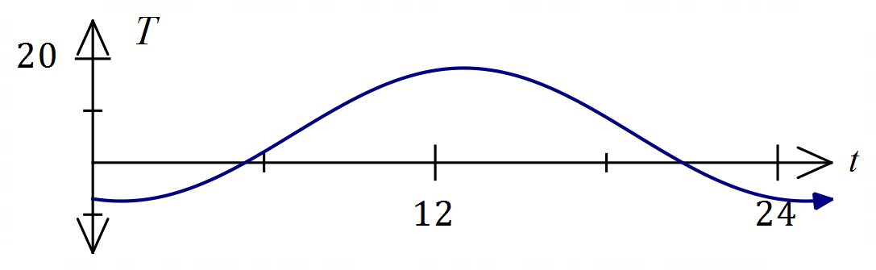
Specific behaviours
axes with indication of scale and sinusoidal graph
ü correctly locates minimum and maximum

(b) Determine an algebraic model for $T$ as a function of $t$. (4 marks)
Solution (Using sin)
Model with $T=a\sin\left(k\left(t+b\right)\right)+c$
Using period: $k=\frac{2π}{24}=\frac{π}{12}$
Amplitude: $a=\frac{18.2-(-7.4)}{2}=12.8$
Mean temp: $c=18.2-12.8=5.4.4$
Phase shift: $b=-7$

$$T=12.8\sin\left(\frac{π}{12}\left(t-7\right)\right)+5.4$$

Specific behaviours
indicates period, value of $k$
ü amplitude $a$ and mean $c$
ü phase shift
ü correct model

Solution (Using cos)
Model with $T=c-a\cos\left(k\left(t+b\right)\right)$
Using period: $k=\frac{2π}{24}=\frac{π}{12}$
Amplitude: $a=\frac{18.2-(-7.4)}{2}=12.8$
Mean temp: $c=18.2-12.8=5.4$
Phase shift: $b=-1$

$$T=5.4-12.8\cos\left(\frac{π}{12}\left(t-1\right)\right)$$

Specific behaviours
indicates period, value of $k$
ü amplitude $a$ and mean $c$
ü phase shift
ü correct model

(c) Use your model to determine the proportion of the day that the temperature at the campsite was below $-2°$C. (2 marks)
Solution
$T=-2$ when $t=4.645, t=21.355$
Proportion of day:

$$\frac{\left(24-21.355\right)+4.645}{24}=\frac{7.29}{24}≈0.30 \text{or} 30\%$$

Specific behaviours
values of $t$
ü correct proportion

Question 17 (6 marks)
(a) Given that $A=\left[\begin{matrix}a-2 & -8 \\ a+2 & 2-a\end{matrix}\right]$, determine the value(s) of the real constant $a$ so that $A$ is its own inverse. (3 marks)
Solution
Require $A^{2}=I$:
$$A^{2}=\left[\begin{matrix}a^{2}-12a-12 & 0 \\ 0 & a^{2}-12a-12\end{matrix}\right]$$

$$a^{2}-12a-12=1 \\ \left(a+1\right)\left(a-13\right)=0 \\ a=-1, a=13$$

Specific behaviours
indicates that $A^{2}=I$
ü indicates $A^{2}$
ü both solutions to $A_{1,1}^{2}=1$

(b) Let $B=\left[\begin{matrix}-2 & 2 \\ 4 & -3\end{matrix}\right]$ and $C=\left[\begin{matrix}-6 \\ 11\end{matrix}\right]$. Determine $X$ when $4X=3BC+B^{2}X$. (3 marks)
Solution
$$4X-B^{2}X=3BC \\ \left(4I-B^{2}\right)X=3BC \\ X={\left(4I-B^{2}\right)}^{-1}×3BC$$

$$4I-B^{2}=\left[\begin{matrix}-8 & 10 \\ 20 & -13\end{matrix}\right], {\left(4I-B^{2}\right)}^{-1}=\left[\begin{matrix}13/96 & 5/48 \\ 5/24 & 1/12\end{matrix}\right], 3BC=\left[\begin{matrix}102 \\ -171\end{matrix}\right]$$

$$X=\left[\begin{matrix}-4 \\ 7\end{matrix}\right]$$

Specific behaviours
indicates (post) factoring of $X$
ü indicates correct equation for $X$
ü correct matrix $X$

Question 18 (8 marks)
(a) $6$ students from Class A, $8$ from Class B and $9$ from Class C have nominated for the $3$ places available in the team for a mathematics competition. Determine the number of different teams that can be formed if

(i) the students are chosen from the same class. (2 marks)
Solution
$$\left(\begin{matrix}6 \\ 3\end{matrix}\right)+\left(\begin{matrix}8 \\ 3\end{matrix}\right)+\left(\begin{matrix}9 \\ 3\end{matrix}\right)=20+56+84=160 \text{teams}$$

Specific behaviours
uses combinations
ü correct number

(ii) at least $2$ students in the team are chosen from Class A. (2 marks)
Solution
$$\left(\begin{matrix}6 \\ 2\end{matrix}\right)\left(\begin{matrix}17 \\ 1\end{matrix}\right)+\left(\begin{matrix}6 \\ 3\end{matrix}\right)\left(\begin{matrix}17 \\ 0\end{matrix}\right)=255+20=275 \text{teams}$$

Specific behaviours
identifies both cases
ü correct number

(b) Prove that for $n≥3$, $\overset{n}{ }C_{3}+\overset{n}{ }C_{2}=\overset{n+1}{ }C_{3}$. (4 marks)
Solution
$$LHS=\overset{n}{ }C_{3}+\overset{n}{ }C_{2} \\ =\frac{n!}{3!\left(n-3\right)!}+\frac{n!}{2!\left(n-2\right)!} \\ =\frac{(n-2)n!}{3!(n-2)\left(n-3\right)!}+\frac{3×n!}{3×2!\left(n-2\right)!} \\ =\frac{n⋅n!-2n!}{3!\left(n-2\right)!}+\frac{3n!}{3!\left(n-2\right)!} \\ =\frac{n⋅n!+n!}{3!\left(n-2\right)!} \\ =\frac{(n+1)!}{3!\left(n+1-3\right)!} \\ =\overset{n+1}{ }C_{3} \\ =RHS$$

Specific behaviours
expresses LHS using factorials
ü obtains common denominator
ü simplifies to single fraction
ü completes proof

Question 19 (8 marks)
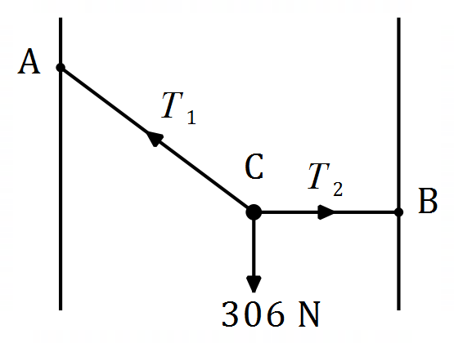
A small object $C$ of weight $306$ N is suspended above
level ground and between two vertical walls by two
light inextensible strings. The walls are $192$ cm apart.

Point $A$ lies on one wall so that string $AC$ is $185$ cm
long and point $B$ lies on the other wall so that string
$BC$ is horizontal and $88$ cm long.

(a) Determine the tension $T_{1}$ in string $AC$. (3 marks)
Solution
Let $D$ be vertically below $A$ so that $ADC$ is a right triangle.
Then $DC=192-88=104 \text{cm}$.

$$∠CAD=\sin^{-1}{\frac{104}{185}}=34.2°$$

Resolving vertically: $T_{1}\cos{34.2°}=306⇒T_{1}=370 \text{N}$

Specific behaviours
angle between $AC$ and wall
ü resolves horizontally
ü tension $T_{1}$

(b) String $BC$ is lengthened so that the height of $C$ above the ground decreases by $29$ cm and $∠ACB=90°$. Determine the tension $T_{2}$ in string $BC$. (5 marks)
Solution
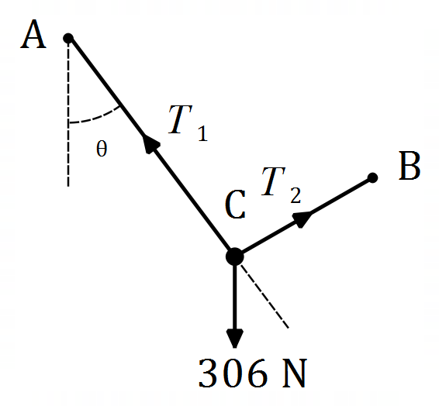
Resolve $∥BC$: $T_{2}=306\sin{θ}$

$$AD_{OLD}=\sqrt{{185}^{2}-{104}^{2}}=153$$
$$AD_{NEW}=153+29=182$$

$$\cos{θ}=\frac{182}{185}⇒θ=10.33°$$

$$T_{2}=306\sin{10.33°}=54.9 \text{N}$$

Specific behaviours
ü resolves parallel to $T_{2}$
equation for $T_{2}$
ü determines $AD$
ü angle $θ$
ü tension $T_{2}$

Question 20 (8 marks)
A common proof that $\sqrt[3]{3}$ is irrational begins by assuming that $\sqrt[3]{3}$ is rational, so that $\sqrt[3]{3}=\begin{matrix}a \\ \overline{b}\end{matrix}$ .

(a) Describe two properties of variables $a$ and $b$ that the proof requires, other than $b≠0$.
(2 marks)
Solution
$a$ and $b$ are integers and have no common factor.

Specific behaviours
states both are integers
ü states no common factor, divisor, etc

The next step obtains the relationship $a^{3}=3b^{3}$, from which it is deduced that $a=3A, A∈Z$.

(b) Prove, using the contrapositive, that if $a^{3}$ is a multiple of $3$ then so is $a$. (4 marks)
Solution
Contrapositive: If $a$ is not a multiple of $3$ then neither is $a^{3}$.

Note: $a$ must be of the form $3k+1$ or $3k+2$, $k∈Z$ so that it is $1$ or $2$ more than an integer multiple of $3$.

Case $1$: $a=3k+1$ so that
$$a^{3}=27k^{3}+27k^{2}+9k+1=3\left(9k^{3}+9k^{2}+3k\right)+1$$

Case $2$: $a=3k+2$ so that
$$a^{3}=27k^{3}+54k^{2}+36k+8=3\left(9k^{3}+18k^{2}+12k+2\right)+2$$

It can be seen in each case that $a^{3}$ is not an integer multiple of $3$.
As the contrapositive is true then the original statement must be true.

Specific behaviours
writes contrapositive
ü identifies cases for $a$ in terms of some constant integer
ü shows $a^{3}$ is not multiple of $3$ for one case
ü shows $a^{3}$ is not multiple of $3$ for other case and concludes

(c) Complete the proof that $\sqrt[3]{3}$ is irrational. (2 marks)
Solution
Since $a=3A$ then $a^{3}=3b^{3}⇒{\left(3A\right)}^{3}=3b^{3}⇒b^{3}=3(3A^{3})$.

Thus $b^{3}$ and $b$ are also multiples of $3$.

Hence $a$ and $b$ are both multiples of $3$ - a contradiction of the initial assumption and so $\sqrt[3]{3}$ is irrational.

Specific behaviours
deduces that $b$ is multiple of $3$
ü indicates contradiction

Question 21 (8 marks)
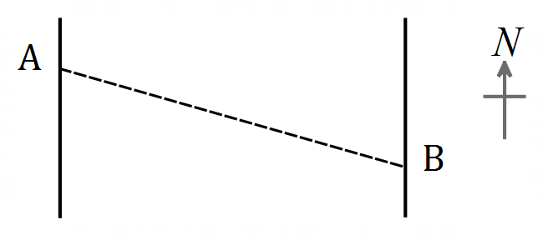
Points $A$ and $B$ lie on opposite sides of a river so that
$B$ is $240$ m away from $A$ on a bearing of $105°$.
A uniform current flows due north in the river
between $A$ and $B$ at $0.32$ m/s.

Sam can swim at a steady speed of $1.2$ m/s and
plans to swim from $A$ to $B$ and then back to $A$.

(a) Determine the bearing Sam should swim to move directly towards $B$ from $A$. (3 marks)
Solution
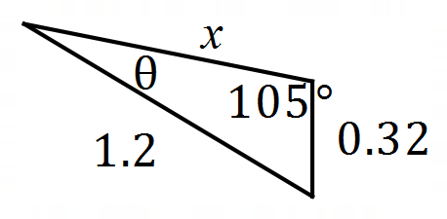
$$\frac{\sin{θ}}{0.32}=\frac{\sin{105°}}{1.2}⇒θ=14.9°$$

Bearing: $105°+15°=120°$

Specific behaviours
diagram with angle
ü equation using sine rule
ü correct bearing

(b) Show that Sam takes $30$ seconds less to swim the return leg than the first leg. (5 marks)
Solution
Speed across ground from $A$ to $B$:
$$\frac{\sin{(180°-105°-14.9°)}}{x}=\frac{\sin{105°}}{1.2}⇒x=1.077 \text{m/s}$$

Time $AB=240÷1.077=223 \text{s}$
Return leg from $B$ to $A$:
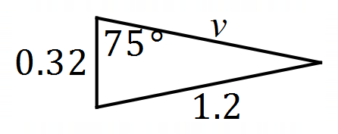
$${1.2}^{2}=v^{2}+{0.32}^{2}-2\left(0.32\right)v\cos{75°}⇒v=1.242 \text{m/s}$$

Time $BA=240÷1.242=193 \text{s}$

Hence $223-193=30$ second less.

Specific behaviours
speed from $A$ to $B$
ü time from $A$ to $B$
ü diagram for $B$ to $A$
speed from $B$ to $A$
ü time from $B$ to $A$ and difference

Supplementary page

Question number: _________

Supplementary page

Question number: _________

Supplementary page

Question number: _________

© 2020 WA Exam Papers. Baldivis Secondary College has a non-exclusive licence to copy and communicate this document for non-commercial, educational use within the school. No other copying, communication or use is permitted without the express written permission of WA Exam Papers. SN261-161-4.

